School of Education – Directions (Campus Map: http://campusmap.ucdavis.edu/)
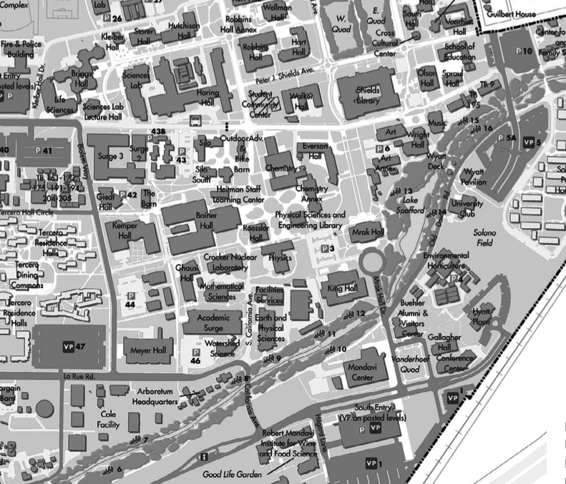
TC3
Lot 46
Lot 47
Lot 5
SOEB
La Rue Rd.
La Rue Rd.
(Formerly California Ave)
Directions to Temporary Classroom 3 (TC3)

From Interstate 80, take the Old Davis Road/UC Davis exit
Turn north towards campus at the end of the off-ramp
- Coming from Sacramento you will turn right
- Coming from San Francisco turn left
Stay on Old Davis Road until you pass the Visitor's kiosk
At the round-about turn left onto La Rue, go over the bridge, then immediately turn left to continue on La Rue
For Lot 46 (“A” permits or “C/Visitors” permits after 5pm)
- This is the first parking lot on your right
- Academic Surge will be directly in front of you (north) as you turn into the parking lot and Temporary Classroom 3 will be just left (west) of Academic Surge.
For Lot 47 (All campus permits or $8.00 Visitors permits)
- Go past the turn for Bioletti Way
- Lot 47 is the large parking lot on your right
- From the parking lot, walk across Bioletti Way
- Walk down the first bike path, which runs between Lot 44 and Meyer Hall
- Continue down the path – TC3 will be just South of the coffee cart; you will approach from the back

Directions to School of Education Building (SOEB)

From Sacramento
Take Interstate 80 West
Exit at Richards Blvd/Downtown Davis; you will be on Richards Blvd going North
Go through the first stoplight & under the railroad trestle
At the 2nd stoplight, veer left onto 1st Street and proceed until you reach the entrance to campus
Turn left onto A Street , passing the two-story, sage colored building that is the School of Education
Continue to Lot 5 on Old Davis Road.

From San Francisco
Take Interstate 80 East
Exit at the UC Davis exit & turn left on Old Davis Road
Follow the road past the Visitor’s Information Booth
Continue straight on Old Davis road, past the Conference Center and the Hyatt Place hotel
Old Davis Road goes in between Lots 5 and 5A, to A Street
From Lot 5, walk to A Street to get to the two-story, sage colored building that is the School of Education
*Old Davis Road was modified in December, 2012 – you can no longer travel by car on Arboretum Drive*

