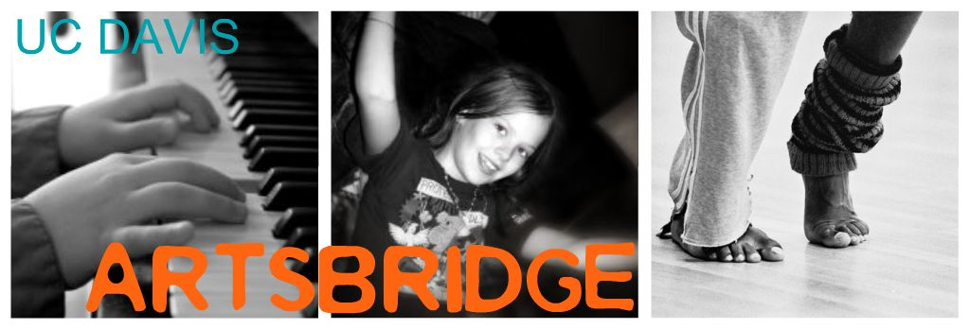

Host Application for ArtsBridge Project

Type or Print Name of Your Institution: ______________________Date:_____________

Address of Host School: __________________________________________________

School Telephone: ________________________ FAX: _________________________

Classroom Teacher Applying: _______________________________________________

Classroom Teacher e-mail address (required): ____________________________

Teacher Home Phone: ____________________ FAX: (_____)_____________________
(This information will only be given to the scholar assigned to you to facilitate timely communication.)

Teacher Home Street address: _________________________________________________

City and Zip: ___________________________________________________________

School District: ______________________________________________________________

Please indicate your experience with ArtsBridge (check one):

❒ This is a first-time application to ArtsBridge
❒ I have participated in the ArtsBridge program before

Principal approving this application: __________________________________________

Does Classroom Teacher agree to be present in the classroom during all ArtsBridge project sessions?  Yes  No
Will Classroom Teacher attend an orientation meeting if required?  Yes  No

Grade level of students to be taught: ____ Total number of pupils in classroom: ______

The classroom teacher and the scholar will coordinate their schedule once an assignment has been made.

To help us with initial schedule matching, please indicate any days/times which would be most ideal for an ArtsBridge project: ____________________________________________________________________________

Language(s) spoken in the classroom:________________________________________

ArtsBridge is intended to serve classrooms currently deficient in standards-based visual and performing arts content. Please answer the following questions regarding the current state of arts instruction in your classroom:

Do you feel your classroom is currently deficient in standards-based visual and/or performing arts instruction?  Yes  No

On average, how many hours of visual and/or performing arts instruction do your students receive per week?_____________________

I have read and agree to the ArtsBridge America Host Guidelines:

Signature of the Classroom Teacher

Note: The more flexible you can be re: session times and days, the more likely we will be able to assign a scholar to you.

Please feel free to contact us at 530 752 5076, or e-mail Lara Downes at lmdownes@ucdavis.edu if you have any questions or concerns. We will contact you to confirm receipt of your application.

You may fax this completed application to Lara Downes at (530 754 5519 or mail it to:

Lara Downes: ArtsBridge Director
CRESS Center, School of Education
UC Davis
1 Shields Avenue
Davis CA 95616

