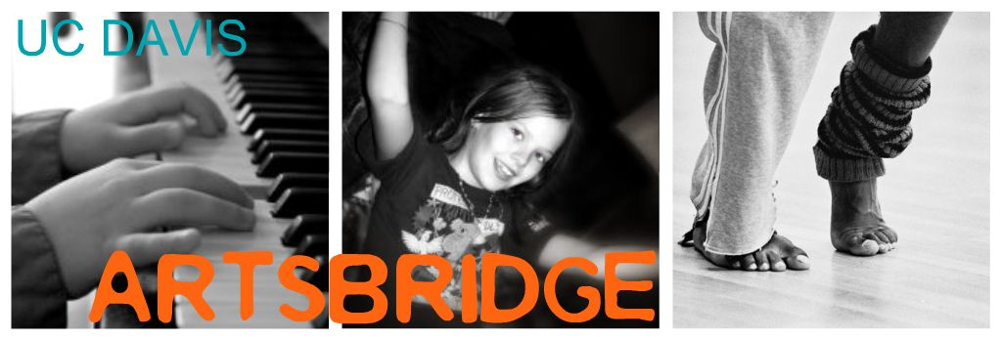

Scholar Application Form

Return completed application to Staci Garcia: slsteadman@ucdavis.edu. Incomplete applications will NOT be processed.

ArtsBridge internships are available to registered UC Davis majors and minors. Please do not submit an application if you are uncertain if you have the time for ArtsBridge service. Projects require a minimum of 10 pupil contact hours (meeting one hour once a week). You must be available for scheduled meetings.

CANDIDATE INFORMATION:
NAME: (LAST, FIRST, M.I.) Print your name

EMAIL ADDRESS:

Student ID #:

LOCAL ADDRESS (NUMBER & STREET, CITY, STATE, ZIP)

TELEPHONE:

PERMANENT ADDRESS:

GRADUATE STUDENT : _____ UNDERGRADUATE STUDENT:

MAJOR:

# UNITS YOU PLAN TO TAKE DURING INTERNSHIP:

EXPECTED GRADUATION DATE:

YEAR IN SCHOOL GPA:

LIST TWO UC DAVIS FACULTY MEMBERS WHO CAN COMMENT ON YOUR WORK
(DO NOT LIST TEACHING ASSISTANTS):

NAME: DEPARTMENT:

NAME: DEPARTMENT:

LIST LANGUAGES (EXCLUDING ENGLISH) IN WHICH YOU ARE FLUENT:

DO YOU HAVE A CAR?

NUMBER OF WEEKLY HOURS YOU ARE ABLE TO TEACH

PREVIOUS EXPERIENCE AS A TEACHER OR YOUTH LEADER:

ArtsBridge provides internships to highly qualified UC Davis Arts majors who give K-12 classroom instruction in art, dance, drama, music, and the digital arts in schools within Yolo, Sacramento and Solano counties. ArtsBridge develops original arts education projects that are tied to community partnerships with public schools and their local neighborhood arts and cultural organizations. The ArtsBridge Scholar works collaboratively with the classroom teacher to create and teach unique lessons in the arts, which are linked to state standards as well as individual classroom needs. The Scholar provides weekly hands-on instruction for up to 10 weeks. All registered majors and minors, undergraduate or graduate students from the departments of Art, Music, and Theater & Dance are eligible to apply to become ArtsBridge Scholars.

The ArtsBridge Scholar works with the classroom teacher who has agreed to be present and participate in the project. The teacher is expected to advise the scholar on lesson plans and play an active role in the scholar’s instruction of pupils. ArtsBridge projects should be integrated into the school day and link to classroom curricula. Our goal is to involve pupils directly in developing arts knowledge and skills, and the creation of art. Host teachers are encouraged to learn from the scholars so that they may themselves include arts projects in future classes or build their own expertise

Projects should be designed for a class of 25-30 pupils. Scholars are expected to develop lesson plans after consultation with the classroom teacher. ArtsBridge will provide forms for lesson plans. Scholars are required to maintain a typed narrative journal of the project progress.

Since most ArtsBridge Scholars are new to teaching, ArtsBridge will provide orientation meetings to explain policies and procedures and to bring together scholars and host teachers. Attendance at these meetings is mandatory.

For more information, please visit artsbridge.ucdavis.edu

