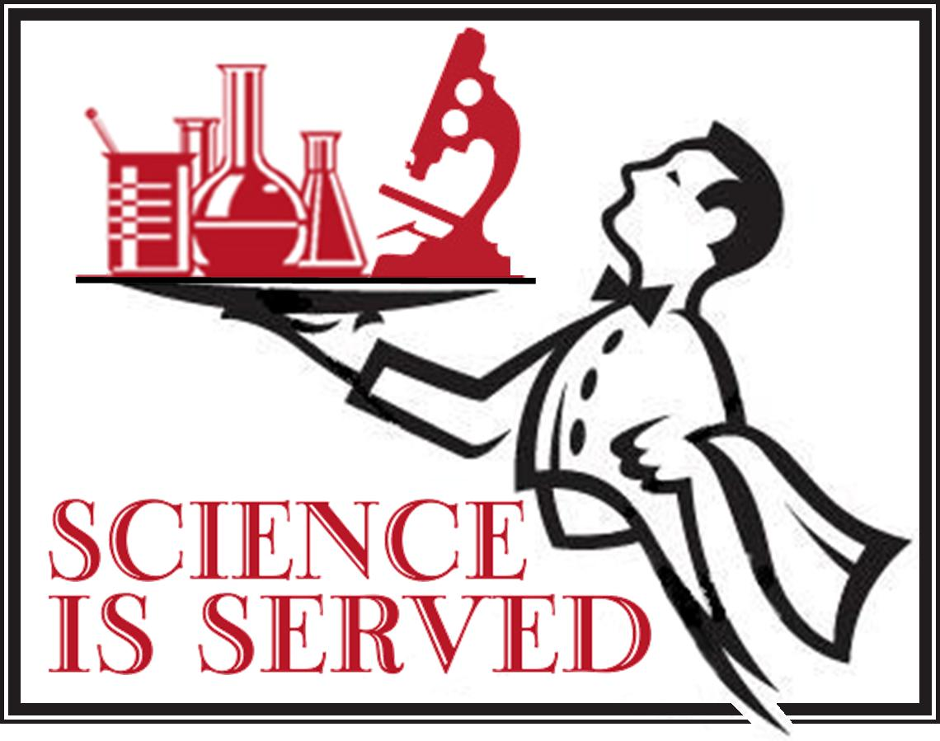The Sacramento Area **Dinner With A Scientist** will be held Thursday May 10, 2018 at the West Sacramento Civic Center Galleria, 1110 West Capitol Ave. West Sacramento.

**Dinner With a Scientist**

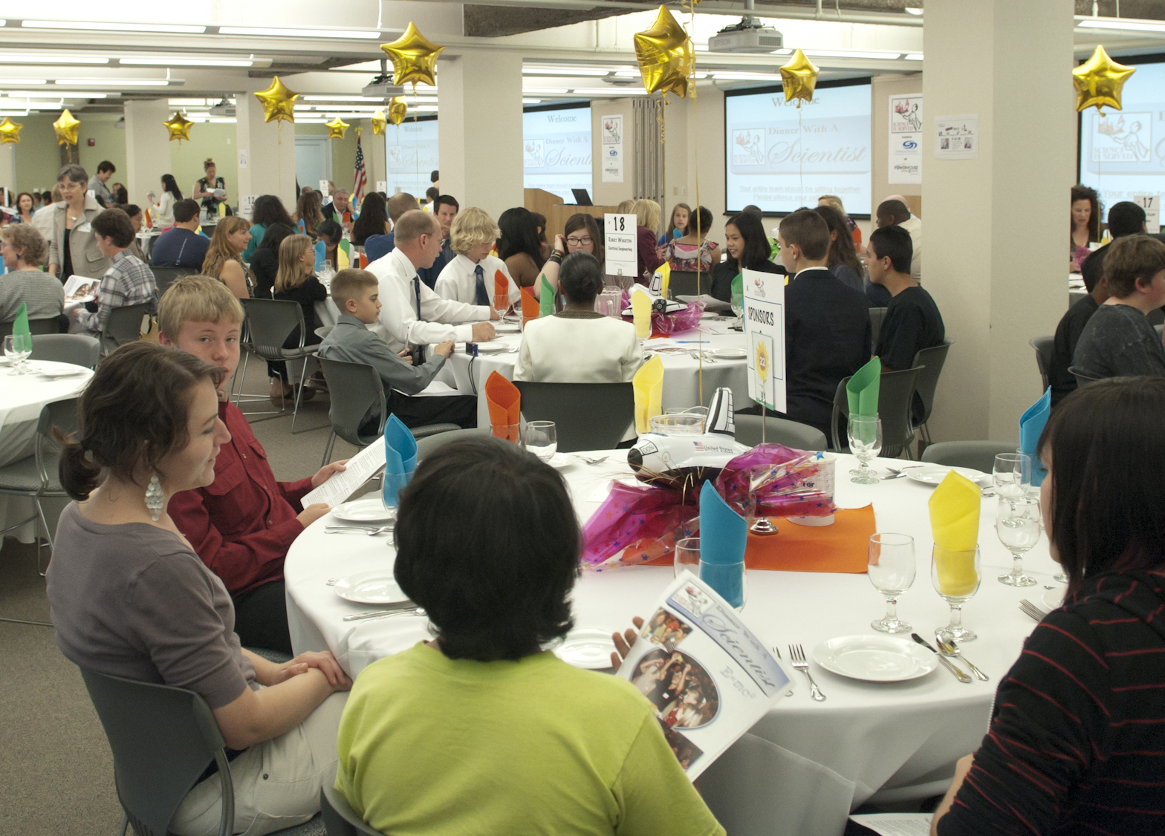At Dinner With A Scientist, students and scientists engage in discussions, participate in a Science Challenge and enjoy a catered gourmet dinner.  Space is limited for this popular event so register early!

Teachers from high schools and middle schools are invited to bring 3 students to Dinner With A Scientist. The Sacramento Area Science Project, the Yolo County Office of Education, and the Powerhouse Science Center will host the event.

The scientists who have been invited to participate will be coming to discuss their careers or the research that they are working on. Students are encouraged to be prepared with questions for the scientists, hopefully to gain insight as to how they too can become a scientist.

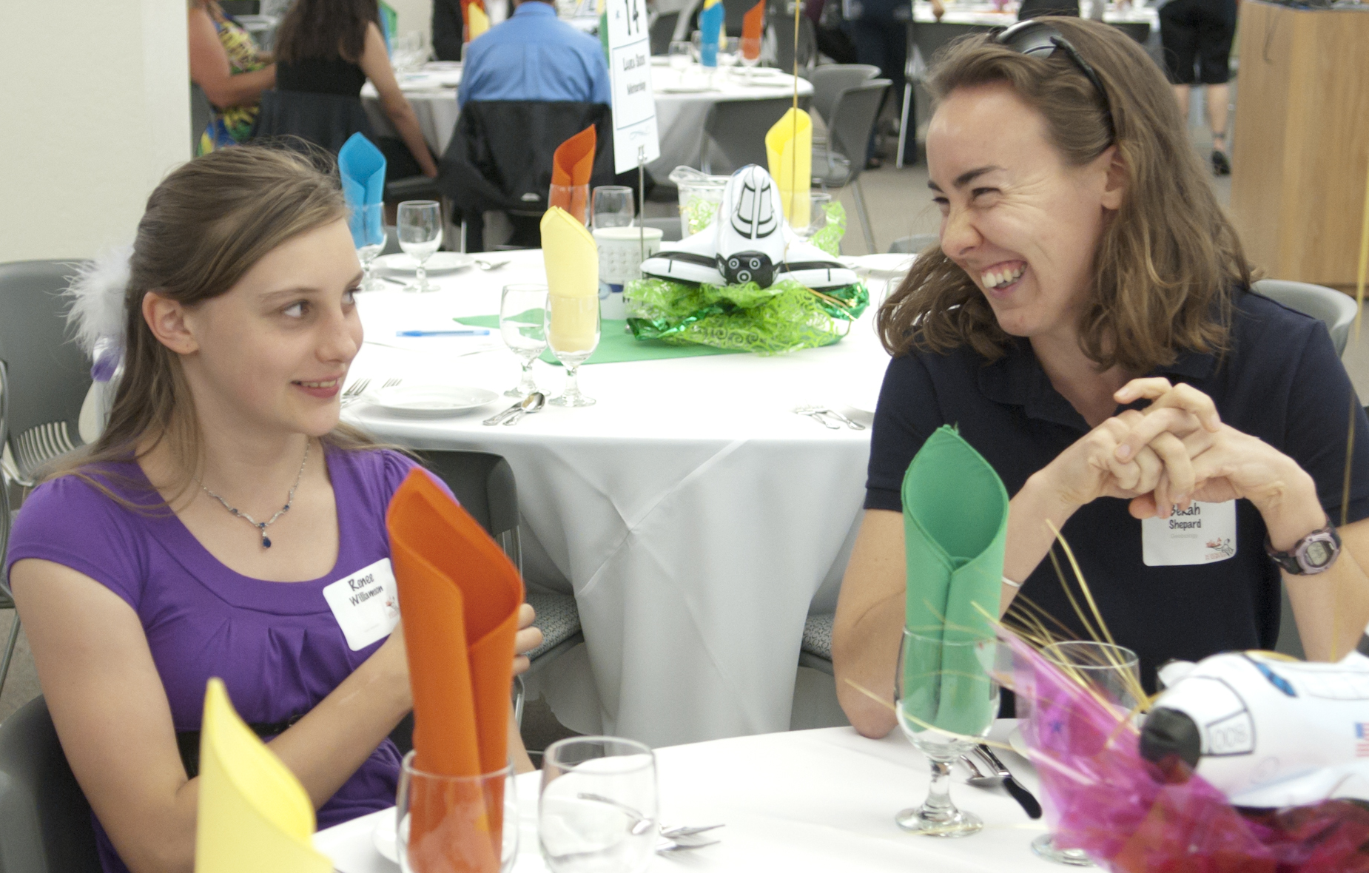

*“I want to congratulate you on the wonderful “Dinner with a Scientist” event. It was a very enjoyable evening and it gave me the opportunity to connect with some amazing high school teachers in our area.” Maria Marco – UC Davis, Food Science & Technology*

*“Hello! My name is Tony Hackett, and I was one of the lucky students to have the opportunity to have dinner with you at McClellan this evening. Recollecting on the evening, I realized that your presentation and personal pizzazz really sparked my interest in the field of biotechnology, and science as a whole… Thank you so much!” Tony Hackett – student*

**http://education.ucdavis.edu/general-information/dinner-scientist**

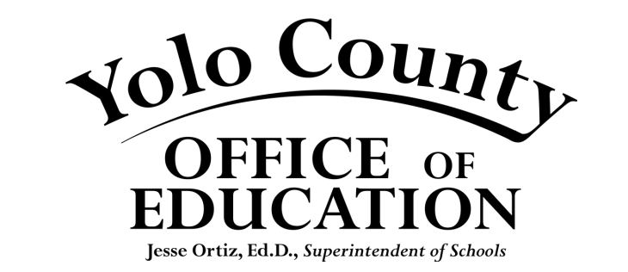 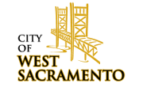 Macintosh HD:Users:laurashafer:Desktop:PSC_logo_cmyk_FNL.pdf

